Task
• Please try to configure Chrome Browser and navigate to https://www.amazon.in/
• Search for Laptops.
• Print the total number of links on the page.
Also print the link and link text of the page.

Code: in this prog 1st we are searching the text laptop and then and then in that page we are counting the number of links as all links are having anchor tag so have given a in the code and by the for loop its giving the links count and also link text
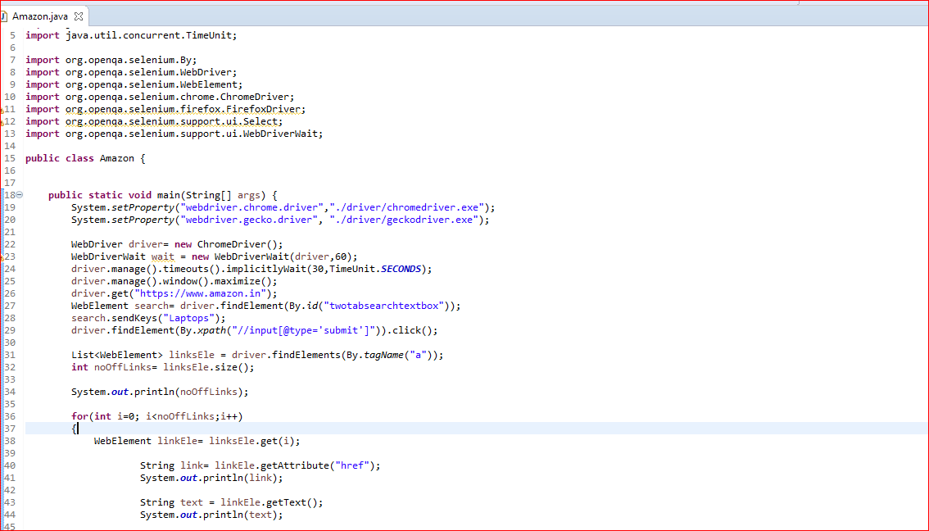

Console screen shot
